EchoVolt: Ultrasound Signal Detection and Reconstruction

Sadiya Anha   
*CSE Department*   
BRAC UniversityDhaka, Bangladesh   
[REDACTED]

Atif Islam Arian  
*CSE Department*   
BRAC UniversityDhaka, Bangladesh   
[REDACTED]Kazi Hasan Imteaz  
*CSE Department*   
BRAC UniversityDhaka, Bangladesh   
[REDACTED]

Md,Azmain Iktider  
*CSE Department*   
BRAC UniversityDhaka, Bangladesh   
[REDACTED]

# Abstract

This project demonstrates a complete signal processing chain, converting a physical measurement into a digital format and back to an analog signal using fundamental electronic components and a microcontroller. An ultrasonic sonar sensor measures distance, which is processed by an Arduino Uno to generate a corresponding analog voltage. This analog signal is fed into a Flash-type Analog-to-Digital Converter (ADC), built using comparators and a priority encoder (IC74148), which encodes the voltage into an 3-bit digital output. This 3 bit output are taken to arduino inputs from where, if arduino receives logic 1 the output rotates the switch to -5V (-|Vref|), and if the arduino receives logic 0 the output rotates the switch to 0V (GND). The digital bits are then processed by a Digital-to-Analog Converter (DAC), implemented with an R-2R ladder (Variant 1) network and an operational amplifier (LM324), to reconstruct the original analog voltage. The final output voltage is measured with a voltmeter, validating the entire conversion cycle. This project provides a practical and comprehensive understanding of data acquisition, digital encoding, and analog reconstruction within embedded systems, bridging the gap between theoretical concepts and hardware implementation.

# Implementation

## *Theory & Design*

The core objective of this project is to illustrate the fundamental processes of ADC and DAC conversion. The system workflow is as follows:

1. Data Acquisition & Analog Generation: The HC-SR04 ultrasonic sensor measures the distance to an object. The Arduino Uno reads this measurement and maps it to a specific output voltage on its analog pin, effectively acting as a programmable analog source.
2. Analog-to-Digital Conversion (ADC): The generated analog voltage is fed into a Flash ADC circuit. This circuit uses multiple comparators (LM324) to simultaneously compare the input voltage against a set of reference voltages derived from a resistor ladder. This code is then fed into a priority encoder (IC74148), which converts it into an 3-bit binary number.
3. Inverting Encoded Bits: The 3-bit digital output from the encoder is connected to arduino which results with logic 0 or logic 1 which rotates the motor to -5V or 0V (GND) respectively.
4. Digital-to-Analog Conversion (DAC): Then this -5V and 0V fed into an R-2R ladder DAC. This network of precision resistors divides the current proportionally based on the significance of each bit. The summed currents are converted back into a single analog voltage by an operational amplifier (741 Op Amp) configured as a summing amplifier.
5. Analog Validation: The final reconstructed analog voltage from the DAC is measured using a voltmeter, completing the signal processing loop and verifying the accuracy of the conversion process.

## *Circuit Design*

The main components used in the circuit are:

* Arduino Uno (Microcontroller for sensor interfacing and initial analog signal generation)
* Ultrasonic Sonar Sensor HC-SR04 (Distance measurement)
* LM324 Quad Op-Amp IC (Used as comparators in the Flash ADC)
* IC74148 (8-Line to 3-Line Priority Encoder, part of the ADC)
* SG90
* 741 Op-Amp (Used in the output stage of the DAC)
* Resistors
* Capacitors
* Breadboard & Jumper Wires (Circuit assembly)
* Power Supply/Battery (Providing necessary voltages for ICs and Op-Amps)
* Voltmeter (Measuring the final analog output).

## *Circuit Diagram*

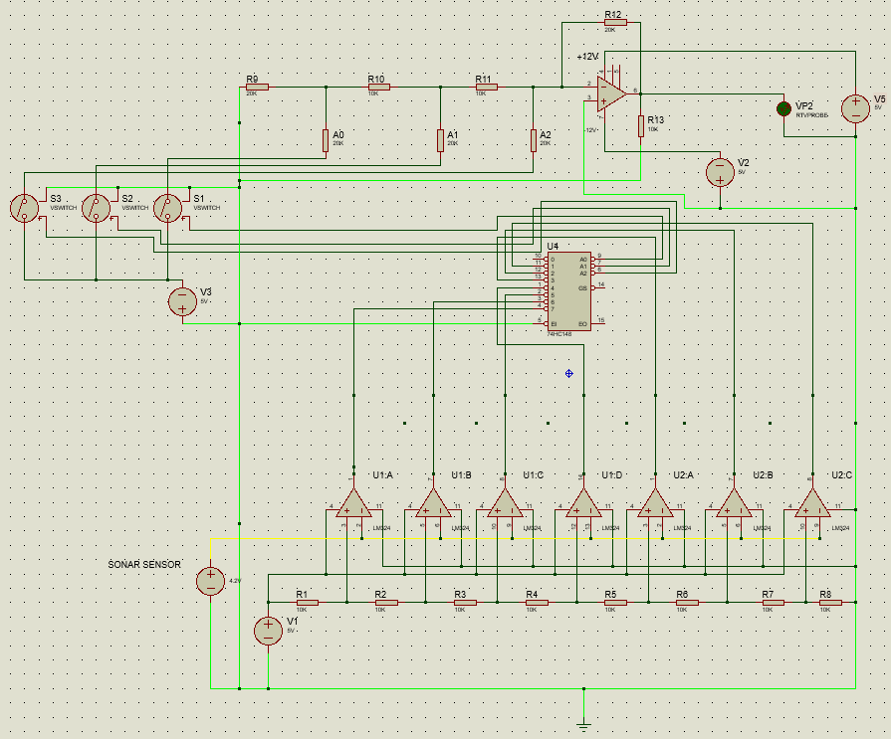

## *Circuit Setup*

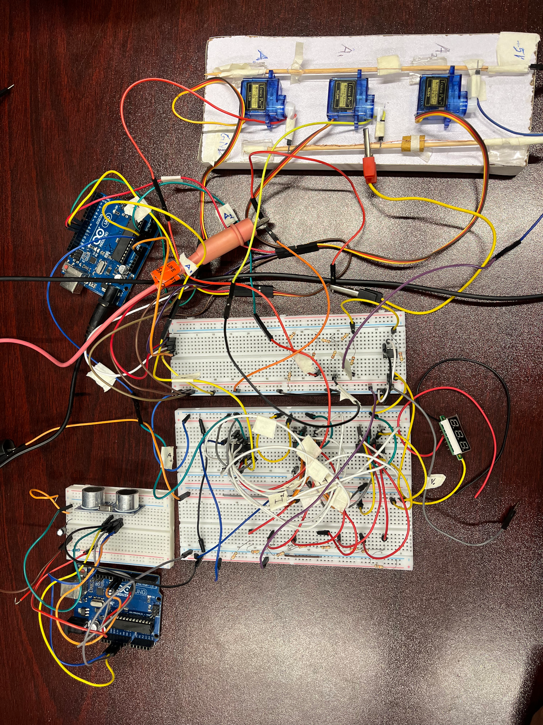

## *Challenges & Troubleshooting*

# Conclusion

## *Summary of Outcomes*

This project successfully designed, implemented, and demonstrated a complete analog-to-digital-to-analog signal conversion system. The core objectives were achieved: a physical distance measurement from an ultrasonic sensor was acquired by an Arduino, converted into a corresponding analog voltage, and then processed through a discrete hardware chain. The system effectively encoded this analog signal into an 8-bit digital format using a Flash ADC circuit with a priority encoder. Subsequently, the digital data was accurately reconstructed back into an analog voltage by an R-2R ladder DAC. The final output, measured on a voltmeter, confirmed the validity of the entire conversion process, closing the signal loop. This project served as a practical and comprehensive application of key concepts in embedded systems and digital signal processing, successfully bridging theoretical knowledge with hands-on hardware implementation.

## *Future Improvements*

Potential future enhancements for this project include increasing the system's resolution by migrating to a 10 or 12-bit architecture for greater accuracy, and improving reliability by replacing the discrete ADC and DAC circuits with dedicated integrated circuits. The functionality could be extended by implementing serial data transmission to a secondary microcontroller for processing or to a PC for real-time visualization via a custom graphical interface. Furthermore, the system's versatility could be demonstrated by adapting it to interface with a wider array of analog sensors, such as those for temperature or light, and its signal fidelity could be significantly improved by incorporating a regulated power supply and advanced filtering to mitigate noise

##### References

1. P. Horowitz and W. Hill, "*The Art of Electronics*", 3rd ed., Cambridge, U.K.: University Press, 2015.
2. A. S. Sedra and K. C. Smith, "*Microelectronic Circuits*", 7th ed. New York, NY, USA: Oxford University Press, 2014.
3. Arduino Foundation, "*Arduino Uno Rev3 Documentation*", ⁦[https://docs.arduino.cc/hardware/uno-rev3⁩](https://docs.arduino.cc/hardware/uno-rev3%E2%81%A9) , accessed May 2023.